**Module Title**

**Internet Technologies**

**Type Portfolio Coursework**

**Year**

**2024-25**

CS & DF- L3_sem-2

**Student Name: Osama Jat**

**UWE ID: 24030174**

**Assignment Submission Date: 26-6-2024**

**Week: 2**

TCP/IP

TCP/IP

-The name “TCP/IP” refers to an entire suite of data communications protocols.

 -The suite gets its name from two of the protocols that belong to it

TCP/IP is the traditional name for this protocol suite and it is the name used in this book.

- the Transmission control Protocol (TCP) and the Internet Protocol (IP).

-Can identify five layers

◦ Application

◦ Host-to-Host (transport)

◦ Internet

◦ Network Access

◦ Physical

Layers of TCP/IP Reference Model

-There are four layers of the TCP/IP model: network access, internet, transport, and application.

- Used together, these layers are a suite of protocols.

-The TCP/IP model passes data through these layers in a particular order when a user sends information, and then again in reverse order when the data is received.

ISO-OSI Seven Layer Model Recalled

 Physical layer

Data Link layer

Network layer

Transport layer

Session layer

Presentation layer

Application layer

TCP/IP Layers

 Network interface layer

 Internet layer

 Host-to-host transport layer

 Application layer

Layer Properties

 In the following slides, the following is described for each

layer

◦ Layer function

◦ Core protocols

◦ Relationship to ISO/OSI model

Network Interface Layer

 Responsible for sending and receiving TCP/IP packets on the

network medium (physical/Data Link)

 Applicable LAN technologies

◦ Ethernet, Token Ring etc.

 Applicable WAN technologies

◦ X.25 (old), Frame Relay, ATM etc.

 Note that some technologies such as ATM and FDDI may be used

at both the WAN and the LAN levels

Some Core Protocols

 IEEE 802.3, IEEE 802.5 and IEEE 802.11 series of

Protocols

Internet Layer

 Packaging

 Addressing

 Routing

Core Internet Layer Protocols

 IP

◦ A connectionless unreliable protocol that is part of the TCP/IP protocol

suite

 ARP (Address Resolution Protocol)

◦ Resolves IP addresses to MAC addresses

 ICMP (Internet Control Message Protocol)

◦ Diagnostics and error reporting

 (IGMP) Internet Group Management Protocol

◦ Management of group multicast

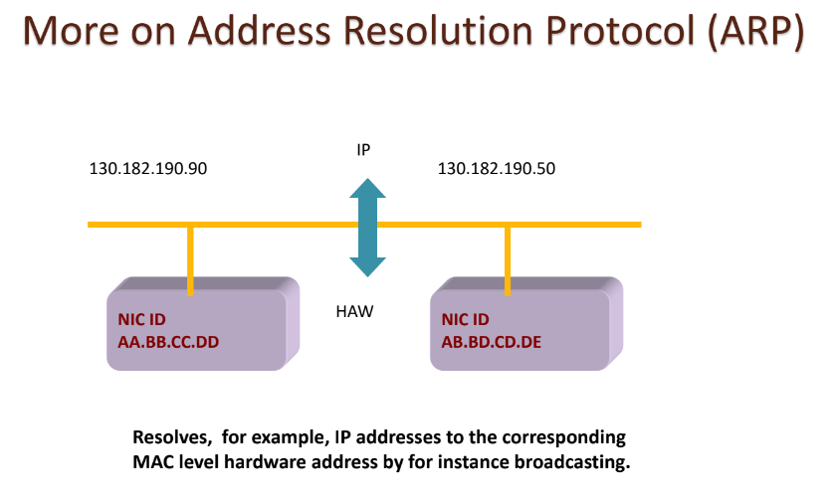TCP

 Transmission Control Protocol (TCP)

 One-to-one and connection-oriented reliable protocol

 Used in the accurate transmission of large amount of

data

 Slower compared to UDP because of additional error

checking being performed